# **VR_12 Report**

## Group

|  |  |  |
| --- | --- | --- |
| Num Participants | N=168 |  |
| w Service dog | 92 | 54.80% |
| Waitlist | 76 | 45.20% |

## Key information

### Descriptive statistics for PCS and MCS

#### Summary Table

##### PCS and MCS overview

|  |  |  |  |  |  |  |  |
| --- | --- | --- | --- | --- | --- | --- | --- |
| Characteristic | | Range | 1st Qu. | Median | Mean | 3rd Qu. | Sd |
|  |  |  |  |  |  |  |  |
| PCS_base |  | 14.44-66.87 | 33.4 | 38.86 | 39.71 | 47.65 | 10.55 |
| MCS_base | | 0.67 - 56.63 | 19.7 | 27.04 | 27.08 | 33.96 | 10.75 |
|  |  |  |  |  |  |  |  |
| Missing |  | 4 |  |  |  |  |  |
|  |  |  |  |  |  |  |  |
|  |  |  |  |  |  |  |  |
| PCS_follow | | 13.10-65.52 | 31.13 | 37.74 | 38.86 | 46.06 | 10.37 |
| MCS_follow | | 4.93 – 59.99 | 24.65 | 32.86 | 32.51 | 40.05 | 11.49 |
|  |  |  |  |  |  |  |  |
| Missing |  | 24 |  |  |  |  |  |

*

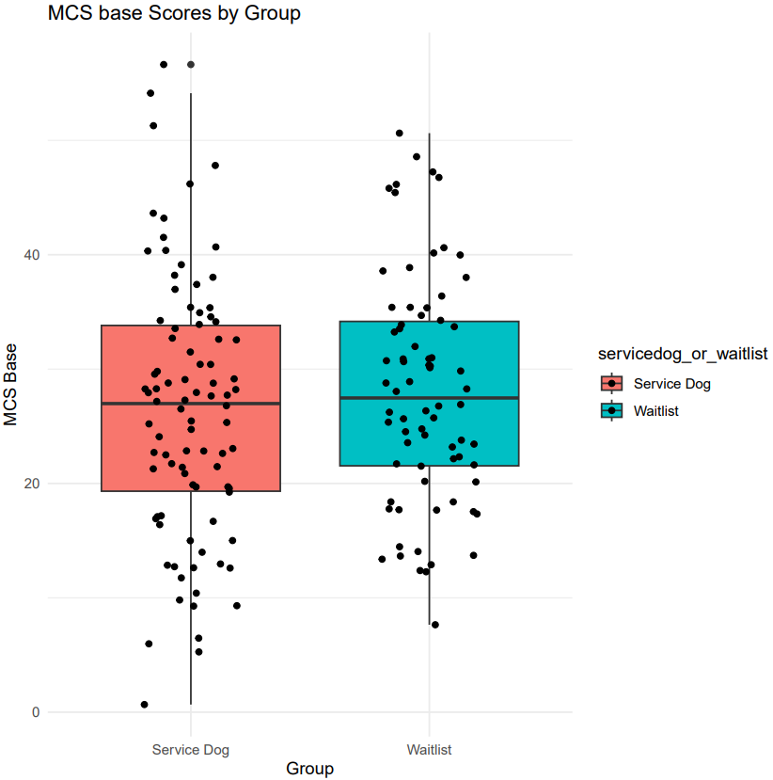

##### PCS and MCS

Comparing SD vs WL on PCS and MCS, at baseline and follow-up

|  |  |  |  |  |  |
| --- | --- | --- | --- | --- | --- |
|  |  | t (two_sample t-test) | df | p-value | confidence interval |
| PCS_base |  | 0.64115 | 140.87 | 0.5225 | -2.257 - 4.424 |
| PCS_follow |  | -0.15659 | 133.82 | 0.8758 | -3.737 - 3.189 |
| MCS_base |  | -1.0213 | 161.34 | 0.3087 | -4.989 - 1.588 |
| MCS_follow |  | 3.3857 | 141.58 | **0.0009** | 2.597 - 9.884 |

Comparing baseline vs follow-up for PCS and MCS

|  |  |  |  |  |  |  |
| --- | --- | --- | --- | --- | --- | --- |
|  |  | t (paired t-test) | df | p-value | confidence interval | mean difference |
| PCS |  | 1.735 | 139 | 0.08502 | -0.1612 - 2.4680 | 1.153379 |
| MCS |  | -5.7813 | 139 | **4.677e-0.8** | -79096 - -3.87823 | -5.893911 |

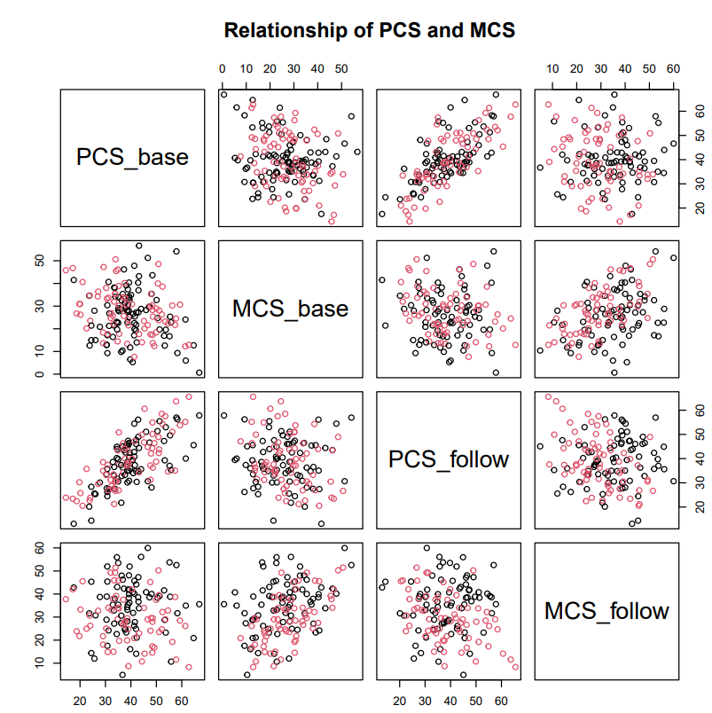

#### Physical Component Summary

##### Mean

##### A graph with red and blue squares Description automatically generatedA graph of a bar chart Description automatically generated with medium confidenceStandard deviation

#### Mental Component Summary

##### A graph of a service dog Description automatically generated with medium confidenceMean

##### A graph of a bar chart Description automatically generated with medium confidenceStandard deviation

### Individual item scores

#### Summary Table

#### Score distribution

Baseline

|  |  |  |  |  |  |
| --- | --- | --- | --- | --- | --- |
| VR12 item | Questions | 1st Qu. | Mean | 3rd Qu. | Missing |
| General health | In general, you would say your health is | 35 | 44.88 | 60 | 3 |
|  |  |  |  |  |  |
| Physical functioning | Moderate activities | 50 | 53.03 | 100 | 4 |
|  |  |  |  |  |  |
|  | Climbing several flights of stairs | 50 | 53.03 | 100 | 3 |
|  |  |  |  |  |  |
| Role Limitations because of Physical Problems | Accomplished less than you would like | 25 | 45.91 | 75 | 3 |
|  |  |  |  |  |  |
|  | Limited in the kind of work or activities | 25 | 48.64 | 75 | 3 |
|  |  |  |  |  |  |
| Role Limitations because of Emotional Problems | Accomplished less than you would like | 25 | 35.15 | 50 | 3 |
|  |  |  |  |  |  |
|  | Didn't do work or other activities as carefully as usual | 25 | 44.39 | 75 | 3 |
|  |  |  |  |  |  |
| Social functioning | How much time health interferes w/social activities | 0 | 30.91 | 50 | 3 |
|  |  |  |  |  |  |
| Mental Health | Felt calm and peaceful | 20 | 26.55 | 40 | 3 |
|  |  |  |  |  |  |
|  | Felts downhearted and blue | 20 | 40.00 | 60 | 3 |
|  |  |  |  |  |  |
| Vitality | Have a lot of energy | 0 | 22.67 | 40 | 3 |
|  |  |  |  |  |  |
| Pain | How much pain interferes with normal work | 25 | 46.06 | 75 | 3 |

Follow-up

|  |  |  |  |  |  |
| --- | --- | --- | --- | --- | --- |
| VR12 item | Questions | 1st Qu. | Mean | 3rd Qu. | Missing |
| General health | In general, you would say your health is | 35 | 48.19 | 60 | 24 |
|  |  |  |  |  |  |
| Physical functioning | Moderate activities | 50 | 59.38 | 100 | 24 |
|  |  |  |  |  |  |
|  | Climbing several flights of stairs | 50 | 57.29 | 100 | 24 |
|  |  |  |  |  |  |
| Role Limitations because of Physical Problems | Accomplished less than you would like | 25 | 50.35 | 75 | 24 |
|  |  |  |  |  |  |
|  | Limited in the kind of work or activities | 25 | 50.17 | 75 | 24 |
|  |  |  |  |  |  |
| Role Limitations because of Emotional Problems | Accomplished less than you would like | 25 | 45.49 | 75 | 24 |
|  |  |  |  |  |  |
|  | Didn't do work or other activities as carefully as usual | 25 | 54.34 | 75 | 24 |
|  |  |  |  |  |  |
| Social functioning | How much time health interferes w/social activities | 25 | 39.24 | 50 | 24 |
|  |  |  |  |  |  |
| Mental Health | Felt calm and peaceful | 20 | 34.41 | 40 | 24 |
|  |  |  |  |  |  |
|  | Felts downhearted and blue | 20 | 49.03 | 65 | 24 |
|  |  |  |  |  |  |
| Vitality | Have a lot of energy | 15 | 27.50 | 40 | 24 |
|  |  |  |  |  |  |
| Pain | How much pain interferes with normal work | 25 | 44.79 | 75 | 24 |

#### Response percentage

##### General health

##### Physical functioning

###### A blue pie chart with numbers and a white background Description automatically generatedModerate activities

###### A blue pie chart with numbers and a white background Description automatically generatedClimbing several flights of stairs

##### Role limitations (Physical problems)

Response percentage of accomplishing less than you would like due to Physical issues (baseline)

###### Accomplished less than you would like

Response percentage of accomplishing less than you would like due to Physical issues (follow-up)

Accomplished less than you would like due to Physical issues (follow-up)

Accomplished less than you would like due to Physical issues (baseline)

###### Limited in the kind of work or activities

Response percentage of limitations in kind of work or activities due to Physical issues (baseline)

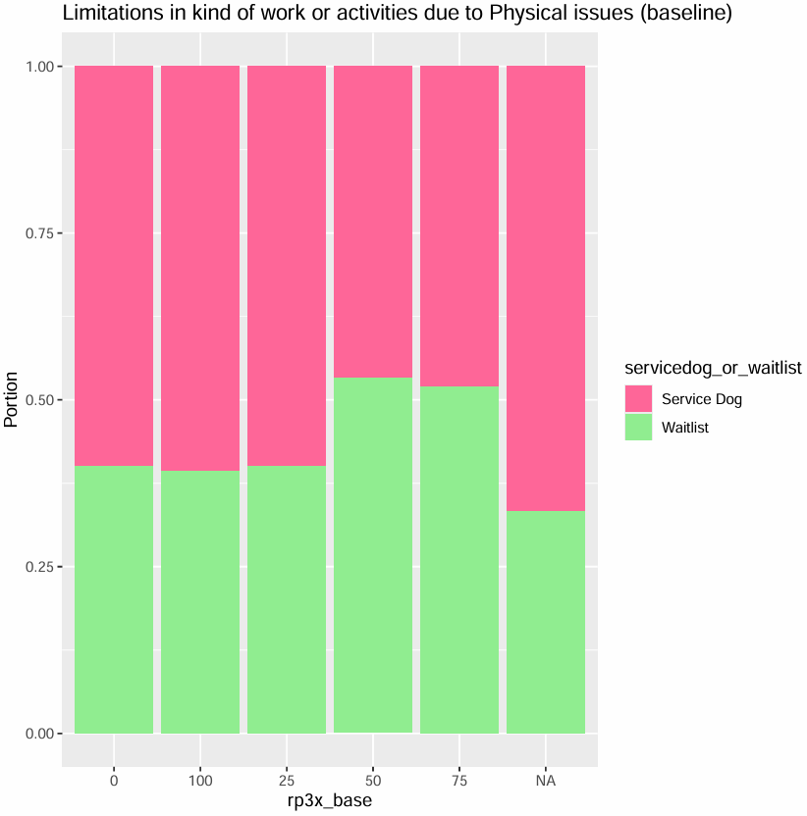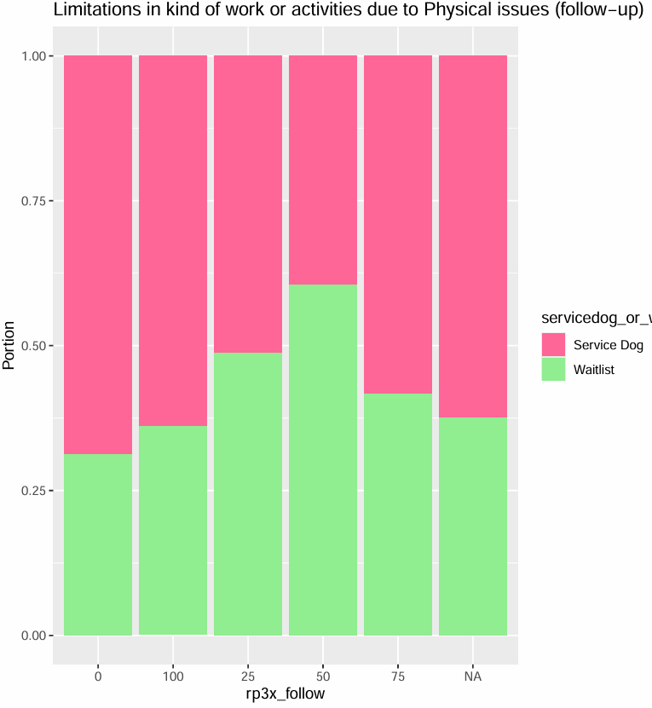

Response percentage of limitations in kind of work or activities due to Physical issues (follow-up)

Limitations in kind of work or activities due to Physical issues (follow-up)

Limitations in kind of work or activities due to Physical issues (baseline)

##### Role limitations (Emotional problems)

Response percentage of accomplishing less than you would like due to Emotional issues (baseline)

###### Accomplished less than you would like

Response percentage of accomplishing less than you would like due to Emotional issues (follow-up)

Accomplished less than you would like due Emotional issues (follow-up)

Accomplished less than you would like due Emotional issues (baseline)

###### Didn't do work or other activities as carefully as usual

Response percentage of didn’t do work or other activities as carefully as usual due Emotional issues due to Emotional issues (baseline)

Response percentage of didn’t do work or other activities as carefully as usual due Emotional issues due to Emotional issues (follow-up)

Didn’t do work or other activities as carefully as usual due Emotional issues (follow-up)

Didn’t do work or other activities as carefully as usual due Emotional issues (baseline)

##### A blue pie chart with text Description automatically generatedA pie chart with numbers and percentages Description automatically generatedA graph with pink and green squares Description automatically generatedA graph of a service dog Description automatically generatedSocial functioning

Response percentage of how much time health interferes with social activities (follow-up)

Response percentage of how much time health interferes with social activities (baseline)

How much time health interferes with social activities (follow-up)

How much time health interferes with social activities (baseline)

##### A pie chart with numbers and percentages Description automatically generatedA blue pie chart with numbers and a white background Description automatically generatedA graph of a number of different colored bars Description automatically generated with medium confidenceVitality

##### A pie chart with numbers and a diagram Description automatically generatedA blue pie chart with numbers and a white background Description automatically generatedPainA graph of a chart Description automatically generated with medium confidenceA graph of a service dog Description automatically generated

##### A blue pie chart with numbers and a white background Description automatically generatedMental Health

###### Feeling calm and peaceful

###### Feeling blue and down

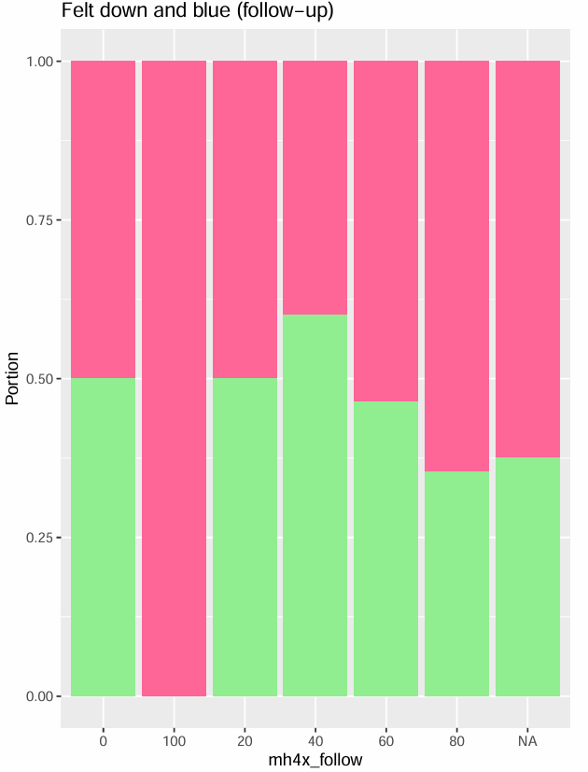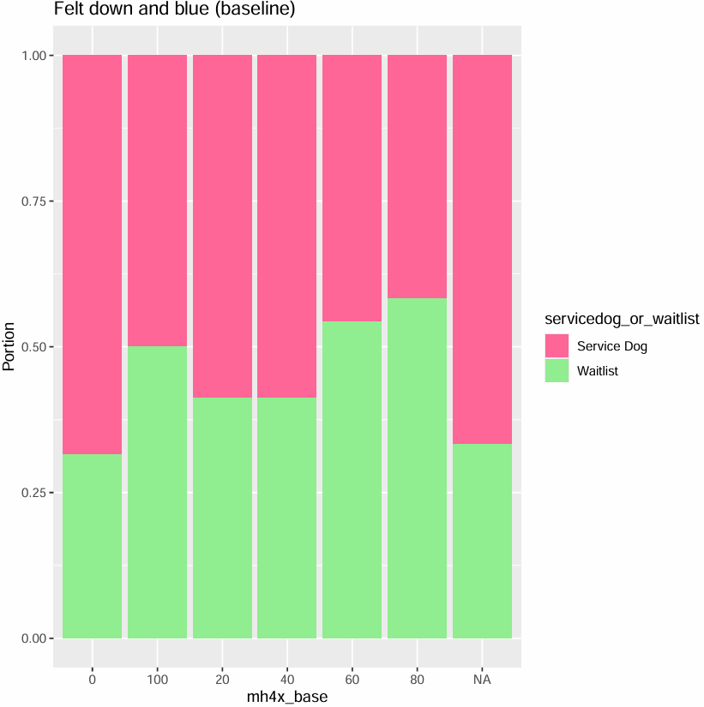

#### A chart of a survey Description automatically generated with medium confidenceScores average

##### General health

Note:

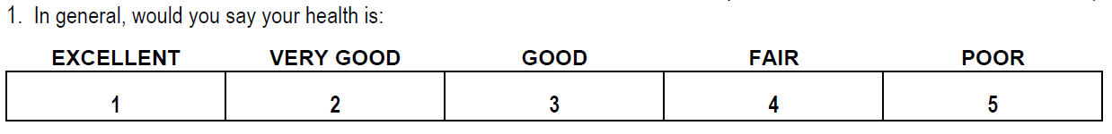

General health criteria is reserved question. The higher the score is the better the health participant has

##### Physical functioning

Note:

Physical functioning criteria are reversed questions. The higher the grade is the more participants’ health affects in activities (moderate activities and climbing several flights of stairs)

###### Moderate activities

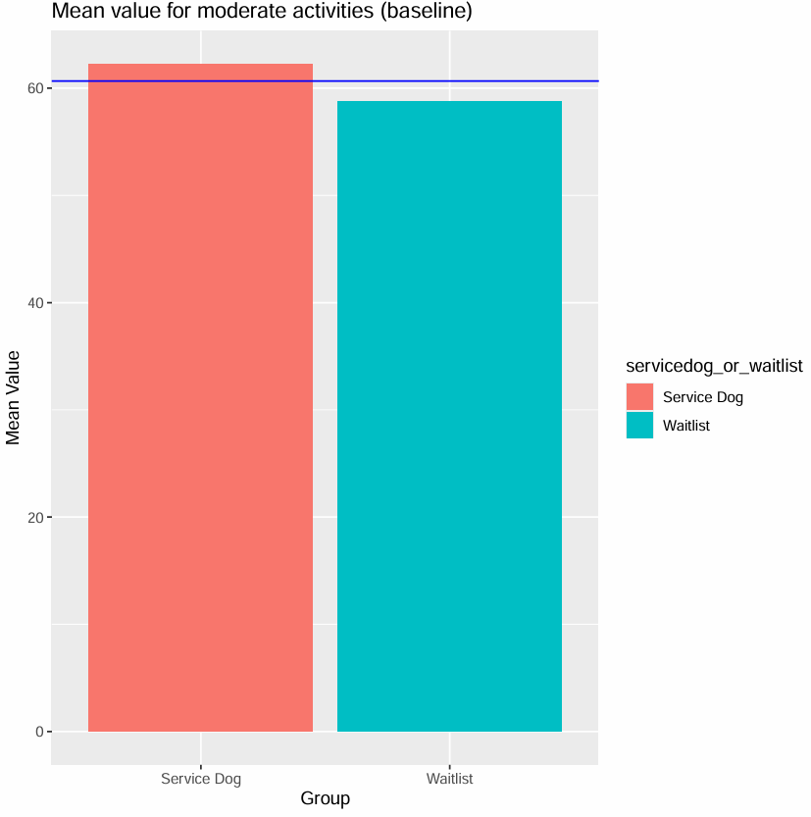

###### Climbing several flights of stairs

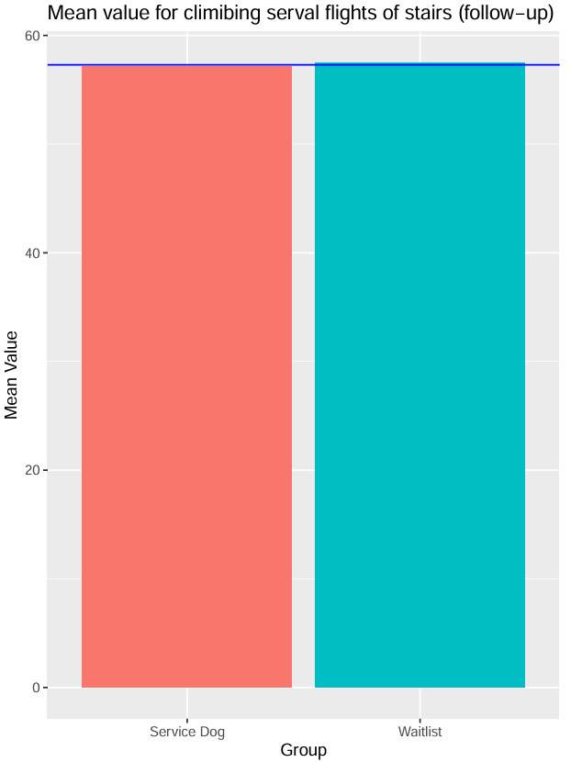

##### Role limitations (Physical problems)

###### Accomplished less than you would like

Mean value of accomplishing less than you would like due to Physical issues (follow-up)

Mean value of accomplishing less than you would like due to Physical issues (baseline)

###### Limited in the kind of work or activities

Mean value of limitations in kind of work or activities due to Physical issues (baseline)

Mean value of limitations in kind of work or activities due to Physical issues (follow-up)

##### Role limitations (Emotional problems)

###### Accomplished less than you would like

Mean value of accomplishing less than you would like due to Emotional issues (baseline)

Mean value of accomplishing less than you would like due to Emotional issues (follow-up)

###### Didn't do work or other activities as carefully as usual

Mean value didn’t do work or other activities as carefully as usual due Emotional issues (follow-up)

Mean value didn’t do work or other activities as carefully as usual due Emotional issues (baseline)

##### Social functioning

Mean value of how much time health interferes with social activities (follow-up)

Mean value of how much time health interferes with social activities (baseline)

##### Pain

Mean value of how much pain interferes with normal work (follow-up)

Mean value of how much pain interferes with normal work (baseline)

##### Mental Health

###### Feeling calm and peaceful

###### Feeling blue and down

